Муниципальное автономное учреждение дополнительного образования

«Рязанский городской дворец детского творчества»

УЧЕБНО-ДИДАКТИЧЕСКИЙ МАТЕРИАЛ
Автор: Козлова Маргарита Анатольевна, педагог дополнительного образования

Тренировочные задания по грамматике
для младших школьников
как приложение к дополнительной образовательной программе "Солнечный английский"
(2-й год обучения)

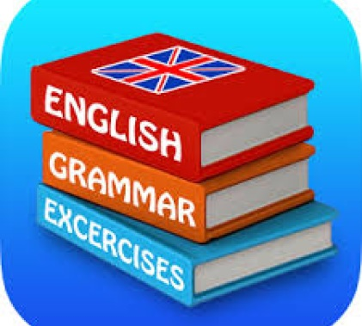

г. Рязань, 2020
Тренировочные задания по грамматике для младших школьников как приложение к дополнительной образовательной программе "Солнечный английский" (2-й год обучения). Автор-составитель Козлова М.А., педагог дополнительного образования МАУДО «РГДДТ» - Рязань, 2020 г.

Данные тренировочные задания составлены на основе дидактических материалов дополнительной образовательной программы "Солнечный английский" и могут быть использованы на занятиях по английскому языку в объединении «Английский клуб» МАУДО «РГДДТ».
Материал адресован педагогам дополнительного образования по английскому языку и предназначена для практического применения учащимися младшего школьного возраста.

Муниципальное автономное учреждение дополнительного образования
«Рязанский городской Дворец детского творчества»

Пояснительная записка
Настоящие учебно-дидактические материалы включают в себя ряд тренировочных упражнений по грамматике английского языка для младших школьников, занимающихся по дополнительной образовательной программе «Солнечный английский» (2й год обучения). Задания, включенные в данную разработку, основаны на лексико-грамматическом материале учебно-методического комплекса И.А. Шишковой, М.Е. Вербовской «Английский для младших школьников» под редакцией Н.А. Бонк.
Цель данного пособия – значительно дополнить задания по грамматике английского языка, которые в учебнике и рабочей тетради, входящих в учебно-методический комплект «Английский для младших школьников», представлены в недостаточном количестве. Пособие включает в себя тренировочные упражнения по следующим темам:
- глагол-связка «IS» в утверждении, отрицании и вопросе;
- дифференциация артиклей A / AN / THE и их отсутствие;
- дифференциация форм «HAVE GOT / HAS GOT» в утверждении;
- «HAVE GOT / HAS GOT» в утверждении, отрицании и вопросе;
- дифференциация артиклей A / THE и их отсутствие;
- глагол «CAN» в утверждении, отрицании и вопросе;
- дифференциация форм глагола «TO BE» - AM, IS, ARE;
- PRESENT SIMPLE в утверждении, отрицании и вопросе;
- CAN, AM/ IS/ARE, HAVE GOT/HAS GOT, DO/DOES в утверждении, отрицании и вопросе (задания на повторение);
- употребление частицы «TO» после глаголов «LIKE» и «WANT»;
- дифференциация указательных местоимений THIS/THESE и THAT/THOSE;
- структура THERE IS/THERE ARE в утверждении, отрицании и вопросе;
- употребление предлогов места в вопросах и ответах;
- дифференциация форм PRESENT SIMPLE и PRESENT CONTINUOUS в утвердительном предложении (базовый уровень);
Таким образом, настоящий сборник упражнений поможет педагогу решить следующие задачи:
- закрепить теоретические знания и развить практические навыки учащихся
в области грамматики английского языка;
- закрепить знания учащихся в области лексики;
- развить память, внимание и логическое мышление учащихся;
- разнообразить работу на уроке;
Предложенные упражнения представлены в виде ресурсов для печати, которые в ряде случаев рекомендуется разрезать на карточки и использовать в качестве раздаточного материала как для групповой, парной или самостоятельной работы в классе, так и в качестве домашнего задания.
Кроме того, в конце практикума представлено приложение «Английская грамматика в таблицах». Данный справочный материал также можно использовать в качестве ресурсов для печати, поскольку он является неплохим наглядным пособием, достаточно емко отражающим основные аспекты грамматики английского языка для детей, занимающихся по программе «Солнечный английский» в течение 2го года обучения.

Глагол-связка «IS» в утверждении, отрицании и вопросе

Сделай эти предложения отрицательными и задай к ним вопросы. Не забудь изменить порядок слов в вопросительном предложении. (КАРТОЧКА №1)

1. It is a clever dog. _________________________________________________
2. Jane is nice. _____________________________________________________
3. The seal is in the sea. ______________________________________________
4. It is late. ________________________________________________________
5. The pen is on the table. ____________________________________________

_________________________________________________________________

Сделай эти предложения отрицательными и задай к ним вопросы. Не забудь изменить порядок слов в вопросительном предложении. (КАРТОЧКА №2)

1. It is a silly fat cat. ________________________________________________
2. Willy is happy. ___________________________________________________
3. The bee is in the tea. ______________________________________________
4. It is cold today. __________________________________________________
5. The fish is on the dish. _____________________________________________

_________________________________________________________________

Сделай эти предложения отрицательными и задай к ним вопросы. Не забудь изменить порядок слов в вопросительном предложении. (КАРТОЧКА №3)

1. It is a big red fox. _________________________________________________
2. Ben is late. ______________________________________________________
3. The doll is in the box. _____________________________________________
4. It is hot today.____________________________________________________
5. The frog is on the log._____________________________________________

____________________________________________________________________

Дифференциация артиклей A / AN / THE и их отсутствие

Заполни пропуски в предложениях. Используй артикли a / an / the или поставь прочерк, если они не нужны. (КАРТОЧКА №1)

- Give me ______ice cream, please. 2) Jane likes ______ice cream, ______sweets and ______cakes. 3) This is ______nice red coat. That is _______nice yellow dress. I like ______coat and ______dress. 4) Kate, take _______apple, please. _______apple is on _______plate. 5) Cats like ______fish, dogs like ______meat. 6) ______fish is on ______dish. 7) Mike and his dad can see ______old boat. 8) Tim has got _____lot of toys. 9) My little bird lives in ______cage. ______cage is big. 10) Max likes ______old toys.
____________________________________________________________________

Заполни пропуски в предложениях. Используй артикли a / an / the или поставь прочерк, если они не нужны. (КАРТОЧКА №2)

1) I can see _____lot of nice sweets and cakes on ______ plate. 2) Jane has got ______friend. It’s ______nice black dog. 3) Sandy can see ______big bird in _______sky. 4) Kate likes _______tea, _______ jam and ______apples. 5) Take ______ice cream, Mike. ______ice cream is nice. 6) This is _____big sofa. That is ______little bed. 7) This ship has got ______lot of white sails. ______ship sails well. 8) Bill and Tim can see ______old carrot in ______snow. They can make _____big snowman. 9) ‘Let’s sing ______nice, old song’, my dad says. 10) _____birds, _____bees and ______flies fly high in _____sky.

_______________________________________________________________

Заполни пропуски в предложениях. Используй артикли a / an / the
или поставь прочерк, если они не нужны. (КАРТОЧКА №3)

- Kate likes _______nice dolls, Ben likes ______big balls. 2) It is ______big seal. It lives in _______sea and eats _______fish. 3) Don’t make ______noise, boys! 4) I can see ______ice cream on ______dish. ‘Don’t take _____ice cream, Andy’, my dad says. ‘It’s cold”. 5) Give me ______apple, please. I like ______apples. 6) My dad and I can see _______ boat in ______lake. ______boat is old. 7) Bill is ______very noisy boy. He can make ______lot of noise. 8) It’s winter. It’s cold. I can see _______old apple in ______tree. 9) Mike can ride ______bike, fly ______kite and play ______chess very well. 10) I like _____winter. I like _______white snow. I like to play ______hockey, make ______snowman and play ______snowballs in ______winter.

Дифференциация форм «HAVE GOT / HAS GOT» в утверждении

Выбери и обведи подходящее слово из двух предложенных.
(КАРТОЧКА №1)

1) I have got / has got a lot of pens and pencils in my bag. 2) Sandy and Andy has got / have got a lot of sweets. 3) Kate has got / have got a nice yellow dress. 4) We has got / have got a lot of nice long songs. 5) Jane have got / has got a little green bird. Her bird has got / have got a big cage. 6) Pete is happy. He have got / has got lot of friends. 7) This hen has got / have got seven little yellow chicks. 8) That ship have got / has got a big white sail. 9) My friend and I has got / have got a lot of white, red and yellow roses. 10) My cat has got / have got big green eyes and a little red nose.

__________________________________________________________________________

Выбери и обведи подходящее слово из двух предложенных.
(КАРТОЧКА №2)

1) The snowman have got / has got a nice red nose. 2) Tim and I have got / has got a lot of snowballs. 3) I has got / have got a big nice cake and a lot of nice sweets. 4) The seal have got / has got a lot of nice fish. 5) Kate and Jane have got / has got a lot of white plates and dishes. 6) The girl have got / has got a big nice doll. The doll has got / have got a little nose and big green eyes. 7) Bill has got / have got three little yellow birds. The birds has got / have got a big cage. 8) The hen and the cock have got / has got five little chicks. 9) Pete’s dog has got / have got a little red ball. 10) I have got / has got a big black bike and a nice white kite.

_______________________________________________________________

Выбери и обведи подходящее слово из двух предложенных.
(КАРТОЧКА №3)

1) Mike have got / has got a lot of big and little ships. The ships have got / has got white, red and black sails. 2) Tony’s dog have got / has got big black eyes and a big cold nose. 3) My friend Kate and I like carrots. We have got / has got a lot of nice red carrots on the dish. 4) Jane’s cats have got / has got a rope, a mat and a ball. 5) Max have got / has got a thick black pencil and a thin red pen on the table. 6) Kate has got / have got a white, a red and a yellow rose. 7) I has got / have got a nice clock in the box. 8) The cat is happy. It have got / has got a lot of meat on the plate. 9) You have got / has got a lot of nice long songs. 10) Kate’s dolls has got / have got nice dresses and hats.

«HAVE GOT / HAS GOT» в утверждении, отрицании и вопросе

Сделай эти предложения отрицательными и задай к ним вопросы. Не забудь о порядке слов в вопросительном предложении. (КАРТОЧКА №1)

1. I have got a nice computer game. _________________________________
__________________________________________________________________________
2. You have got nice roller skates. ____________________________________
_______________________________________________________________
3. Mike has got a big suitcase________________________________________
_______________________________________________________________
4. Sue has got a nice red suit. _______________________________________
_______________________________________________________________
5. Jane and Mike have got a pen and a pencil. __________________________
_______________________________________________________________
6. My dad and I have got an old boat. _________________________________
_______________________________________________________________
7. The ship has got three white sails. __________________________________
_______________________________________________________________

_______________________________________________________________

Сделай эти предложения отрицательными и задай к ним вопросы. Не забудь о порядке слов в вопросительном предложении. (КАРТОЧКА №2)

1. I have got a nice black coat. ______________________________________
_______________________________________________________________
2. You have got nice sweets and cakes. ________________________________
_______________________________________________________________
3. Tim has got a red cat and a white dog. _____________________________
_______________________________________________________________
4. Kate has got a nice yellow dress. ___________________________________
_______________________________________________________________
5. Bill and Ben have got a nice long song. _____________________________
____________________________________________________________________6. My friend and I have got a ship and a kite. __________________________
____________________________________________________________________7. The hen has got five chicks. _____________________________________
______________________________________________________________

_______________________________________________________

Дифференциация артиклей A / THE и их отсутствие

Заполни пропуски в предложениях. Используй артикли a / the или поставь прочерк, если они не нужны. (КАРТОЧКА №1)

1. Look at _____sky! You can see ______moon and ______lot of stars. 2. It’s hot today. ______sun is high in ______sky. 3. Mike’s got _____ nice black and white football. He can play _______football very well. 4. Lucy’s got ______nice roller skates. She can roller skate very well. 5. I can sing ______nice long song and play _______guitar. 6. ______children like ______sweets and ________ice cream. 7. Sue’s cat can play with ______ball but it can’t catch _______mouse. 8. ______foxes and ______wolves live in _______woods. _______seals live in _______sea. 9. “Let’s go to _______school!”, says Kate. “Oh, no!”, says Bill. “Let’s go to _____ lake and swim!” 10. I can see ______goose and _______duck. ________goose is white. _______duck is black. 11. I am ______little grey mouse. I live in _______nice house._______ house is _______little hole. 12. Tony and Jane are _______pupils. You are ______ pupil too. 13. I can see ______hare. It’s got ______short soft tail. 14. This is ______tall white heron. _______heron lives in ______lake and eats ______ green frogs. 15. I am _______little green frog. I live in ________grass.

_______________________________________________________________

Заполни пропуски в предложениях. Используй артикли a / the или поставь прочерк, если они не нужны. (КАРТОЧКА №2)

1. Ben and Bill are ________good friends. 2. I like _______tea with ______jam and _______cakes. Let’s have _______tea together! 3. “Let’s go to _______woods!” says Kate. “Oh, no! Let’s go to _______park and play!” says Jane. 4. _______bears have got ______short brown tails and ______ sharp (острые) teeth. 5. This is ______pear. I like _______pear. It’s big and nice. 6. _______squirrels live in _______woods. They like ______nuts and ________apples. 7. Sue is _______good pupil. She can read and write very well. 8. This is _______chair. That is _______sofa. I like _______chair and _______sofa. They are nice and soft. 9. “Let’s go to ______school!” say Mike and Jane. 10. ______sun is ______hot yellow star. 11. Mike’s dad says, “Let’s go to ______sea, Mike and Lucy!” “Oh, yes, let’s!” answer _______children. 12. “Don’t take ______thick blue book, Tony! It’s Mike’s”, his dad says. 13. Pete and Tim are _______little boys. They can make ______lot of noise. 14. Kate is ______little girl. She is very nice. She’s got _______big blue eyes and ______small nose. 15. Ben has got _______nice black guitar. He can play _______ guitar very well, but he can’t sing.

Глагол «CAN» в утверждении, отрицании и вопросе

Сделай эти предложения отрицательными и задай к ним вопросы. Не забудь о правильном порядке слов в вопросах. (КАРТОЧКА №1)

1. I can play hockey well. __________________________________________
_______________________________________________________________
2. Mike and Sue can use a computer. _________________________________
_______________________________________________________________
3. Kate can ride a bike. ____________________________________________
_______________________________________________________________
4. Willy can visit Jane. _____________________________________________
_______________________________________________________________
5. Andy’s dog can swim and run very well. ____________________________
_______________________________________________________________
6. My dad and I can fly a big kite. ____________________________________
_______________________________________________________________
7. You can play the guitar well. ______________________________________
_______________________________________________________________

_______________________________________________________________

Сделай эти предложения отрицательными и задай к ним вопросы. Не забудь о правильном порядке слов в вопросах. (КАРТОЧКА №2)

1. I can see a big star in the sky.______________________________________
____________________________________________________________________2. The children can read and write well. _______________________________
____________________________________________________________________3. The fox can catch a big hen. ______________________________________
_______________________________________________________________
4. My friend and I can sing a good song. ______________________________
_______________________________________________________________
5. Lucy can help Bill. _____________________________________________
_______________________________________________________________
6. You can make a nice cake. _______________________________________
_______________________________________________________________
7. Little Tim can play with a ball. ____________________________________
_______________________________________________________________

_______________________________________________________________

Дифференциация форм глагола «TO BE» - AM, IS, ARE

КАРТОЧКА №1
1) Выбери нужную форму глагола to be – am, is или are и заполни пропуски.

1) Tim and Bill ______good pupils. 2) Kate ______a clever girl. She reads and writes well. 3) I _____a happy boy. I’ve got a lot of friends. 4) _______Mike and Bill late? – No, they _______not late. Jane and I _______ late. 5)_______Willy’s cat silly? - No, it ______not silly. Willy’s cat ______ clever. 6) Kate and Jane ______nice girls. 7) This ______my good friend. His name ______Andy. 8) _______you happy? – Yes, I ______. 9) _______Kate and Ben pupils? – No, they _______not. 10) My dad and I _______good friends.

2) Сделай эти предложения отрицательными и задай к ним вопросы.
1) I am lucky. ____________________________________________________
2) You are clever. _________________________________________________
3) Mike is a noisy boy. ____________________________________________
4) Kate is a good pupil. ____________________________________________
5) Tim’s dog is silly. ______________________________________________
6) The children are happy. __________________________________________
7) Mike and I are friends. __________________________________________

_______________________________________________________________

КАРТОЧКА №2
1) Выбери нужную форму глагола to be – am, is или are и заполни пропуски.

1) Apples and pears _______nice. 2) Little Tim ________a very noisy boy. He makes a lot of noise. 3) Herons, ducks and geese (гуси)_______birds. 4) ______you a good pupil? – Yes, I ______5) Kate’s little puppy ______very nice. 6) Jane and I ______happy girls and good pupils. 7) I ______a clever boy. I can read and write very well. 8) ______Jane a good friend? – Yes, she ______. 9) ______you and Mike good friends? – No, we _____not. 10) Jane ______eight. She ______a nice little girl .

2) Сделай эти предложения отрицательными и задай к ним вопросы.
1) I am happy. ___________________________________________________
2) You are lucky. ________________________________________________
3) Pete is a good friend. ____________________________________________
4) Jane is a little girl. ______________________________________________
5) Willy’s bird is blue. _____________________________________________
6) Cats are nice and clever. _________________________________________
7) Pete and I are pupils. ____________________________________________
PRESENT SIMPLE в утверждении, отрицании и вопросе

КАРТОЧКА №1
1) Выбери и обведи подходящее слово из двух предложенных.
1) Willy’s little ships sail / sails well. 2) Andy’s big white kite flies / flys high in the sky. 3) Kate and Jane like / likes milk and jam. 4) This little seal can eat / eats ten big fish. 5) Bees and flies fly / flies high in the sky. 6) Sandy rides / ride a bike well. 7) This big ship with white sails sail / sails in the sea. 8) Jane can read / reads well. 9) Seals and fish lives / live in the sea. 10) Kate make / makes cakes and jam well.

2) Заполни пропуски в предложениях. Используй do / does в вопросительном, а don’t / doesn’t - в отрицательном предложении.
1) I ______like apple juice. 2) Dolphins _______live in the lake. 3) _______Mike ride a bike well? – No, he _______.4) _______this elephant like carrots? – Yes, it _______. 5) My friend Mike ________play the guitar well. 6) _______Sue and Lucy often play hopscotch? – Yes, they _______. 7) Kate ______often make cakes. 8) ______ you swim well? – No, I _______. 9) _______squirrels and hares live in the woods? – Yes, they _______. 10) Phil’s cat _______like meat.

____________________________________________________________________

КАРТОЧКА №2
1) Выбери и обведи подходящее слово из двух предложенных.
1) Mike play / plays the guitar well. 2) Dolphins and seals swims / swim very well. 3) I often skate / skates in the park in winter. 4) Every evening Kate skis / ski in the park in winter. 5) Tony’s cat can run / runs very quickly. 6) My dad and I often roller skate / roller skates in the park together. 7) “What’s in my bag?” ask / asks Lucy. “It’s a big red apple,” answers / answer Tim and Jane. 8) All children like / likes ice cream and sweets. 9) My dad says / say, “It’s hot today! Let’s go the lake and swim!” I say / says, “Ok, let’s!” 10) Tony’s bird live / lives in the cage and sings / sing nice songs.

2) Заполни пропуски в предложениях. Используй do / does в вопросительном, а don’t / doesn’t - в отрицательном предложении.
1) ________elephants carry heavy logs? – Yes, they ________. 2) All children _______like fish. 3) _______Pete’s dog run quickly? – No, it ______. 4) I _______often ski and skate in winter. 5) Mike _______often use a computer. 6) _______Kate sing well? – Yes, she _______. 7) ________you often eat meat and fish? – Yes, I _______. 8) My friend Andy and I ________often play computer games. 9) Little Tim _______ride a bike very well. 10) _______you often roller skate in the park? – Yes, we _______.

PRESENT SIMPLE в утверждении, отрицании и вопросе

Сделай эти предложения отрицательными и задай к ним вопросы. Не забудь, что тебе потребуются слова-помощники do / does в вопросительном, а don’t / doesn’t - в отрицательном предложении.

(КАРТОЧКА №1)
1) I make nice cakes and jam. _______________________________________
____________________________________________________________________2) You read and write well. _________________________________________
_______________________________________________________________
3) Bill often plays football in the park. ________________________________
_______________________________________________________________
4) Sue sings very well. _____________________________________________
____________________________________________________________________5) Willy’s puppy runs very quickly. ___________________________________
_______________________________________________________________
6) My dad and I often go to the lake. _________________________________
____________________________________________________________________7) Pete and Ben like ice cream. ______________________________________
_______________________________________________________________

_______________________________________________________________

Сделай эти предложения отрицательными и задай к ним вопросы. Не забудь, что тебе потребуются слова-помощники do / does в вопросительном, а don’t / doesn’t в отрицательном предложении.

(КАРТОЧКА №2)
1) I like apple juice. ______________________________________________
____________________________________________________________________2) You play the guitar very well. _____________________________________
____________________________________________________________________3) Sandy often roller skates in the park. _______________________________
_______________________________________________________________
4) Lucy often skates and skis in winter. _______________________________
____________________________________________________________________5) The dolphin lives in the sea. _____________________________________
_______________________________________________________________
6) My friend and I go to school. ____________________________________
_______________________________________________________________
7) Herons eat fish and frogs. ________________________________________
_______________________________________________________________

CAN, AM/ IS/ARE, HAVE GOT/HAS GOT, DO/DOES в утверждении, отрицании и вопросе (задания на повторение)

ВАРИАНТ №1
1) Ответь на вопросы. Напиши краткие и полные утвердительные или отрицательные ответы.

1) Do seals swim well? ____________________________________________
2) Can elephants carry logs? ________________________________________
3) Is the sky red? _________________________________________________
4) Does a zebra eat meat? __________________________________________
_______________________________________________________________
5) Can a hen fly? _________________________________________________
6) Have foxes got short tails? _______________________________________
_______________________________________________________________
7) Are bears brown? ______________________________________________
8) Has a wolf got sharp teeth? _______________________________________
_______________________________________________________________
9) Is the moon grey? ______________________________________________
10) Does a plane fly high? __________________________________________
11) Do dolphins live in the lake? _____________________________________
____________________________________________________________________12) Are rats silly? ________________________________________________

2) Сделай эти предложения отрицательными и задай к ним вопросы.

1) The tree is green. _______________________________________________
2) Squirrels like nuts. ______________________________________________
3) Mike and I can play chess well. ___________________________________
_______________________________________________________________
4) Tim has got roller skates. ________________________________________
_______________________________________________________________
5) Seals are grey. _________________________________________________
6) Kate runs quickly. ______________________________________________
7) Hares have got short tails. ________________________________________
_______________________________________________________________
8) I am happy. ___________________________________________________
9) Tim’s dog can swim well. ________________________________________
____________________________________________________________________10) Ben’s cat eats apples. ___________________________________________
_______________________________________________________________

CAN, AM/ IS/ARE, HAVE GOT/HAS GOT, DO/DOES в утверждении, отрицании и вопросе (задания на повторение)

ВАРИАНТ №2
1) Ответь на вопросы. Напиши краткие и полные утвердительные или отрицательные ответы.

1) Have squirrels got stripes? _______________________________________
2) Does a goat like grass? __________________________________________
_______________________________________________________________
3) Are dolphins clever? ____________________________________________
4) Do ducks live in the sea? _________________________________________
_______________________________________________________________
5) Is the moon grey? ______________________________________________
6) Can a mouse run quickly? ________________________________________
7) Is the sun green? _______________________________________________
8) Has a heron got long legs? _______________________________________
9) Do bats fly well? _______________________________________________
10) Can hares swim? _____________________________________________
11) Does a frog eat fish? ___________________________________________
_______________________________________________________________
12) Are zebras brown? _____________________________________________

2) Сделай эти предложения отрицательными и задай к ним вопросы.
1) Sue and Lucy read well. _________________________________________
____________________________________________________________________2) Bill can fly a kite. ______________________________________________
3) We have got a good computer game. _______________________________
_______________________________________________________________
4) Herons are tall white birds. _______________________________________
____________________________________________________________________5) Pete is a good pupil. ____________________________________________
6) The mouse lives in a little hole. ___________________________________
____________________________________________________________________7) I am lucky. ____________________________________________________
8) Kate has got a nice red dress. _____________________________________
_______________________________________________________________
9) The cat can catch a mouse. ______________________________________
_______________________________________________________________
10) I like carrot juice. _____________________________________________
_______________________________________________________________

Употребление частицы «TO» после глаголов «LIKE» и «WANT»

- Поставь частицу «TO» в пробел, если это необходимо.
(КАРТОЧКА №1)
1) Tony likes _____roller skate in the park. He can _____roller skate very well. 2) Kate likes _____cakes with jam. She wants ______make a big nice cake. 3) Pete likes ______pears and apples. Jane wants ______send Pete two big yellow pears and four nice red apples. 4) Sue can _____sing very well. She wants _____sing a good song. 5) Ted’s pets like _____meat. They can _____eat a lot of meat. 6) It’s a rainy day. Kate isn’t happy. She can’t _____go for a walk. 7) Tim likes ______go for a walk in the park. 8) Dolphins like _____children. They like _____play with children very much. 9) I want _____visit Phil and see his little nice puppy. It can ______play with a ball and with its tail. 10) The cat isn’t happy. It wants _____catch a mouse but it can’t _____find it.
2) Соедини две колонки так, чтобы получились связные мини-диалоги.
- Bill wants to go for a walk.  - Dad likes to have tea with jam.  - Jane wants to sing a nice song.  - I want to phone my friend Pete.  - Mike and I want to go to the lake.  - Ted’s puppy likes to play with a ball. | - Let me play the guitar then.  - Please, don’t go! It’s cold today!  - Ok! Let’s go to the park!  - I can give Ted a nice little ball.  - Oh, no! It’s late!  - We’ve got a lot of apple jam.
_______________________________________________________________
- Поставь частицу «TO» в пробел, если это необходимо.
(КАРТОЧКА №2)
1) I like _____winter very much. I like ______skate and ski in winter. 2) Seals and dolphins like ______fish. They can _____ eat a lot of fish. 3) The elephant wants _______ to carry a heavy log. 4) Bill and Tim like ______play tag and hide-and-seek in the park. 5) It’s hot today. Sue and Lucy want ______go to the lake and swim. They can ______swim well. 6) Ben can ______use a computer very well. He likes ______ play computer games too. 7) Tony’s cat is very noisy. It likes _____play with a rope and can ______run very quickly. 8) It’s cold today. My dad and I want ______have tea together. 9) I want ______ go and see my friend Phil but I can’t ______go. It’s late. 10) Pete likes ______songs and music but he can’t ______sing and play the guitar.
2) Соедини две колонки так, чтобы получились связные мини-диалоги.
- Tim and Ben like to run, hop and play tag.  - Kate wants to make a nice cake.  - Mike likes to read books very much.  - Look! The cat wants to play with its tail!  - The children want to play in the park!  - I like to sing very much. And you? | - Oh, yes! It’s very nice and funny!  - It’s hot today! Let’s swim in the sea!  - I can only play the guitar.  - Let me help, please!  - I think he is very clever.  - Oh, yes! They are very noisy boys!
Дифференциация указательных местоимений THIS/THESE
и THAT/THOSE

ВАРИАНТ №1
1) Посмотри на стрелки и напиши начало предложений, используя местоимения this – these / that – those.

1. _______ is a dolphin.

2. _______ are bears.
3. _______ is a zebra.
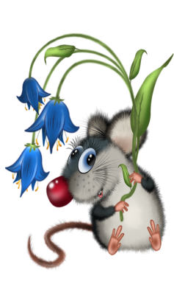
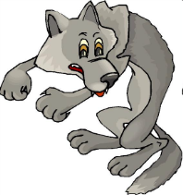
4. _______ are hares.

5. _______ is a wolf.

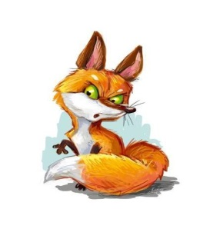
6. _______ is a mouse.

7. _______ are foxes.

8. _______ are elephants.
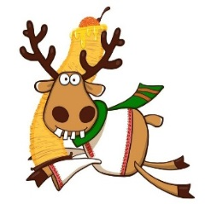
9. _______ is a squirrel.

10. ______ is a deer.

2) Заполни пробелы в предложениях, используя глаголы-связки IS / ARE.

1. These ______clever pupils. 2. This ______a happy girl. 3. That ______ a noisy boy. 4. Those ______silly dogs. 5. This _____a lucky mouse. 6. These ______nice sweets. 7. Those ______bad cakes. 8. That ______ a big lake. 9. These ______little chairs. 10. This ______a long song. 11. Those ______tall trees. 12. That ______ a soft sofa. 13. This ______a sharp knife. 14. These ______beautiful roses. 15. Those ______good books.

Дифференциация указательных местоимений THIS/THESE
и THAT/THOSE

ВАРИАНТ №2
1) Посмотри на стрелки и напиши начало предложений, используя местоимения this – these / that – those.

1. _______ are balloons.

2. _______ is a computer.

3. _______ is a suitcase.
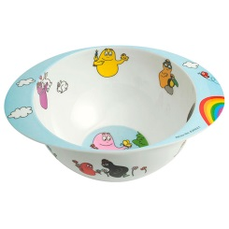
4. _______ are chairs.

5. _______ are plates.
6. _______ is a taxi.

7. _______ are ships.
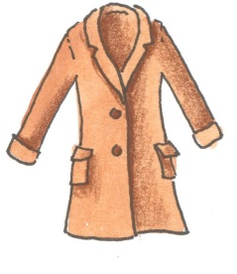
8. _______ are footballs.

9. _______ are coats.
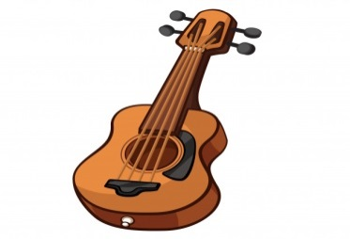
10. ______ is a guitar.

2) Заполни пробелы в предложениях, используя глаголы-связки IS / ARE.

1. Those _______white herons. 2. This ______a grey duck. 3. These ______clean spoons. 4. That _______a yellow pear. 5. Those ______ small plates. 6. This ______ a short house. 7. These ______nice photos. 8. This is ______a blue telephone. 9. Those ______cold snowballs. 10. That ______a hot cake. 11. These ______beautiful dresses. 12. This ______ an old suit. 13. That _______a thick stick. 14. Those ______fat pigs. 15. These ______thin pens.

THERE IS/THERE ARE в утверждении, отрицании и вопросе

ВАРИАНТ №1
1) Заполни пропуски в предложениях связками IS или ARE.

1) There _______a nice flower in the vase. 2) There _______nice curtains on the windows. 3) _______there a brown carpet on the floor? 4) ______there two windows in the living-room? 5) There _______an armchair and a sofa in the living-room. 6) There ______ two yellow armchairs and a sofa in the living-room. 7) There ________no pictures on the wall. 8) There _______no piano in the room. 9) _______there many books in the bookcase? 10) _______there a TV-set on the table? 11) There ______no children in the school. 12) There ______an apple and a pear on the dish. 13) _______there wolves and foxes in the woods? 14) _______there a mouse in the hole? 15) There ______ a blue pencil under the chair.

- Сделай предложения отрицательными и задай к ним вопросы.

1) There is a chair in front of the piano. _______________________________
_______________________________________________________________
2) There is a mat at the door. ________________________________________
____________________________________________________________________3) There are two vases behind the curtain. _____________________________
_______________________________________________________________
4) There are three pictures on the wall. ________________________________
_______________________________________________________________
5) There is a pear on the plate. ______________________________________
_______________________________________________________________
6) There are two frogs in the grass. ___________________________________
_______________________________________________________________

3) Напиши начало каждого предложения, используя слова из рамочки.

Are there Is there an There are five Is there a There are Is there

1. _______________apple on the dish?
2. _______________four dolphins in the sea?
3. _______________cat on the sofa?
4. _______________a chair in front of the piano?
5. _______________three dresses in the suitcase.
6. _______________pencils on the table.

THERE IS/THERE ARE в утверждении, отрицании и вопросе

ВАРИАНТ №2
1) Заполни пропуски в предложениях связками IS или ARE.

1) There ______two squirrels in the tree. 2) There _______a nice vase behind the curtain. 3) _______there a mat at the door? 4) _______there four boxes under the table? 5) There ______no chair in front of the piano. 6) There ______a cake and three sweets on the plate. 7) There ______two armchairs and a big sofa in the living-room. 8) There _______no photos on the walls. 9) ______there a piano next to the bookcase? 10) There _______beautiful red roses in the vase. 11) _______there many children in the park? 12) ______there a kitten in the armchair? 13) There ______a little green and yellow parrot in the cage. 14) There ______a carpet and a mat on the floor. 15) There _______two pencils and a pen in the pencil box.

2) Сделай предложения отрицательными и задай к ним вопросы.

1) There is a computer on the table. _________________________________
______________________________________________________________
2) There is a fox under the tree. _____________________________________
_______________________________________________________________
3) There are four suits in the suitcase. ________________________________
_______________________________________________________________
4) There are two armchairs next to the sofa. ____________________________
______________________________________________________________
5) There is a box behind the door. ____________________________________
_______________________________________________________________
6) There are three children by the lake. ________________________________
_______________________________________________________________

3) Напиши начало каждого предложения, используя слова из рамочки.

Are there There is an There are three Is there a There are There is

1. _______________old hat in the snow.
2. _______________two herons in the lake?
3. _______________pear on the plate?
4. _______________a wolf under the tree.
5. _______________five flowers in the vase.
6. _______________boxes at the door.

Употребление предлогов места в вопросах и ответах
Посмотри внимательно на картинку и ответь на вопросы
(ВАРИАНТ №1)
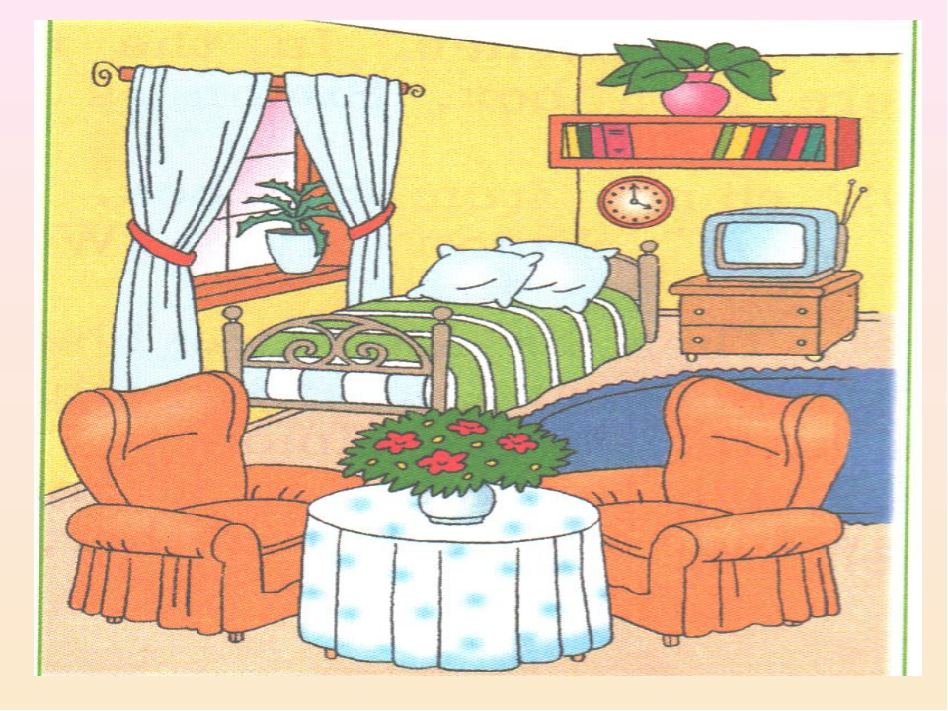
1) What is this?___________________________________________________
2) How many curtains are there on the window? ________________________
_______________________________________________________________
3) What is there behind the curtains? _________________________________
4) What is there at the window? _____________________________________
5) What is there next to the bed? _____________________________________
6) Is there a TV-set in the room? Where is it? ___________________________
_______________________________________________________________
7) What is there above the bed? _____________________________________
8) What is there in front of the bed? _________________________________
9) Is there a bookcase in the bedroom? ________________________________
_______________________________________________________________
10) How many books are there on the book shelf? _______________________
_______________________________________________________________
11) Is there a table in the bedroom? __________________________________
12) Is there a lamp on the table? ____________________________________
_______________________________________________________________
13) Are there three armchairs in the room? _____________________________
_______________________________________________________________
14) Where are the armchairs? _______________________________________

a bedroom – спальня; a plant [pla:nt] – растение; a bedside table – прикроватная тумбочка; above [ə’bɅv] – над; a book shelf – книжная полка;

Употребление предлогов места в вопросах и ответах
Посмотри внимательно на картинку и ответь на вопросы
(ВАРИАНТ №2)
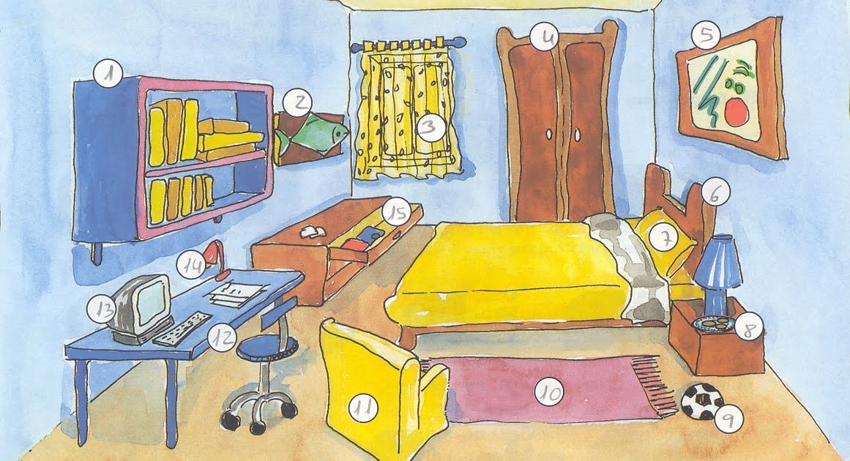
1) Is it a girl’s room or a boy’s room? _________________________________
2) How many windows are there in the room? __________________________
3) Is there a curtain on the window? __________________________________
4) What’s there under the window? ___________________________________
5) What’s there on the right? Is it a bookcase? __________________________
_______________________________________________________________
5) Is there a sofa in the room? _______________________________________
6) What’s there next to the bed? _____________________________________
7) Where is the table? _____________________________________________
8) Is there a computer on the table? ___________________________________
9) What’s there in front of the table? __________________________________
10) Is there an armchair in the room? Where is it? _______________________
_______________________________________________________________
11) Where is the bookshelf? ________________________________________
12) Are there nine books on the bookshelf? ____________________________
_______________________________________________________________
13) How many pictures are there on the walls? _________________________
____________________________________________________________________14) Are there two lamps in the room? _________________________________
____________________________________________________________________15) Is there a carpet on the floor? ____________________________________
16) Is there a ball or a football on the floor? ____________________________

a chest of drawers [t∫est əv ‘drᴐ:iz] – комод; a bedside table – прикроватная тумбочка; a wardrobe [‘wᴐ:drəub] – гардероб; a book shelf – книжная полка; or [ᴐ:] – или;

Дифференциация форм PRESENT SIMPLE и PRESENT CONTINUOUS в утвердительном предложении

ВАРИАНТ №1
- Поставь глагол PLAY в PRESENT SIMPLE и PRESENT CONTINUOUS в утвердительном предложении

PRESENT SIMPLE PRESENT CONTINUOUS
I __________ I ________________
You __________ You ________________
He __________ He _________________
She __________ She ________________
It _________ It _________________
We __________ We _______________
They _________ They ______________

2) Выбери и обведи правильный вариант из двух предложенных.

1) My granny watches / is watching TV every evening. 2) ‘Where is Sue?’ – ‘She watches / is watching TV in the living room. 3) Look! The dolphins are swimming / swim very quickly! 4) Seals and dolphins live / are living in the sea. They swim / are swimming very quickly. 5) I read / am reading books every day. 6) ‘I don’t want to go to the lake now, Pete! I am reading / read a good book!’ his dad says. 7) My dad and granddad often play / are playing chess. My granddad usually wins / is winning. 8) Look! Willy and Andy are playing / play chess! Willy wins / is winning! 9) ‘Where are the children?’ – ‘They are running / run in the park!’ 10) Little children run / are running very quickly.

3) Прочитай текст. Подчеркни предложения, в которых говорится о том, что делают герои СЕЙЧАС одной чертой, а в которых говорится, что они делают ЧАСТО или ОБЫЧНО - двумя чертами.

Look at the picture! My family and I are sitting in the living room. My mum is playing the piano. She plays the piano and sings very well. My dad and grandad are playing chess and grandad is winning. They play chess every evening and grandad usually wins. My granny is sitting on the sofa and reading a book. She likes to read very much. My little brother Willy is sitting on the carpet and playing with his naughty puppy. They are very good friends. They like to play together. They usually play tag and hide-and-seek. My sister Kate and I are having tea with cakes and jam. My granny makes very nice cakes and jam and we often have tea all together!

Дифференциация форм PRESENT SIMPLE и PRESENT CONTINUOUS в утвердительном предложении

ВАРИАНТ №2
- Поставь глагол SLEEP в PRESENT SIMPLE и PRESENT CONTINUOUS в утвердительном предложении

PRESENT SIMPLE PRESENT CONTINUOUS
I __________ I ________________
You __________ You ________________
He __________ He _________________
She __________ She ________________
It _________ It _________________
We __________ We _______________
They _________ They ______________

2) Выбери и обведи правильный вариант из двух предложенных.

1) My dad plays / is playing the guitar every evening. 2) Don’t make noise, Mike and Bill! Kate is playing / plays the piano. 3) My cat and little kittens usually sleep / are sleeping in the box all together. 4) Look at this photo! The cat and the dog are sleeping / sleep together! 5) ‘I can’t see Sam. Where is he?’ – ‘He sits / is sitting in his room’. 6) My little brother Tim often sits / is sitting on the carpet in his room and is playing / plays with his toys. 7) I don’t like fish very much. I usually ea / am eating meat. 8) I usually am eating / eat fish in the evening but now I am eating / eat meat. 9) Elephants carry / are carrying heavy logs very well. 10) Look at the elephants in the picture! They are carrying / carry heavy logs.

3) Прочитай текст. Подчеркни предложения, в которых говорится о том, что делают герои СЕЙЧАС одной чертой, а в которых говорится, что они делают ЧАСТО или ОБЫЧНО - двумя чертами.

Look at the photo! It’s winter. My friends and I are in the park. We often go to the park in winter. The children in the park are playing hockey. Mike and Bill are playing snowballs. Sue and Lucy are making a big snowman. Ben is skiing. He can’t skate but he skis very quickly. Jane is skating. She skates very well. You can also (также) see my dog Spot in the photo. He is playing in the snow and running. But you can’t see me in this photo. I am standing and watching my friends and my pet. I am taking this photo. I often take photos in the park, in the woods and at the lake when (когда) I go for a walk. It’s my hobby and I like it very much! It’s fun!

Литература:
- Шишкова И.А., Вербовская М.Е. Английский для младших школьников под редакцией Н.А.Бонк. – М.: Росмэн, 2015. – 208 с.
ПРИЛОЖЕНИЕ: АНГЛИЙСКАЯ ГРАММАТИКА В ТАБЛИЦАХ
ТАБЛИЦА 1
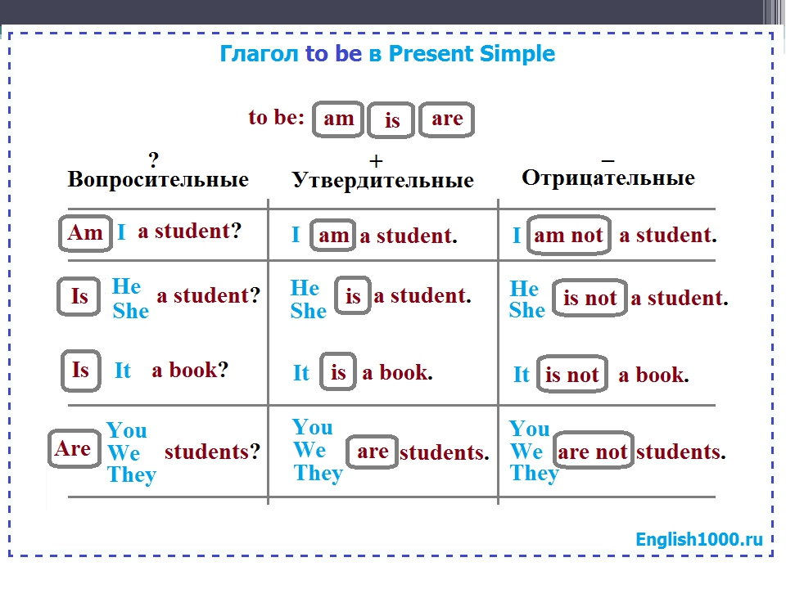
ТАБЛИЦА 2
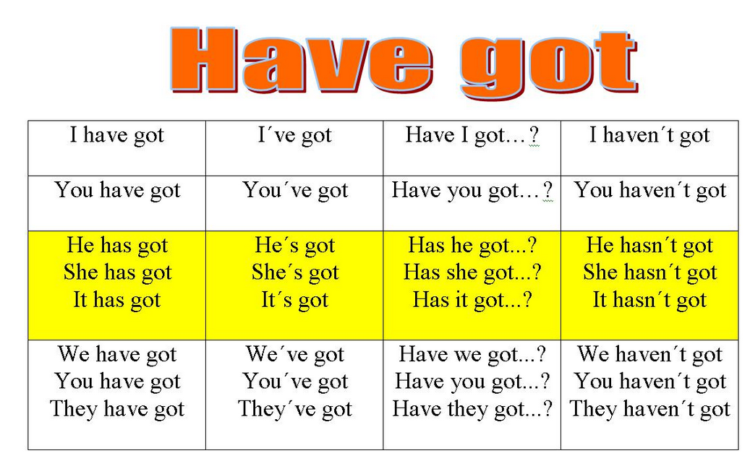

ТАБЛИЦА 3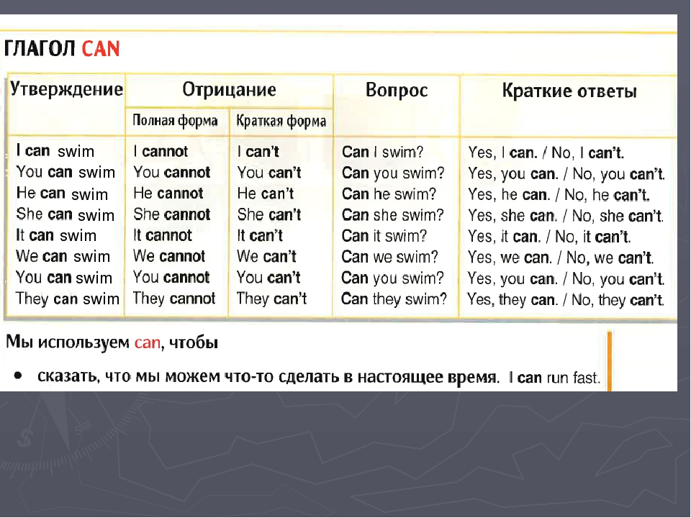

ТАБЛИЦА 4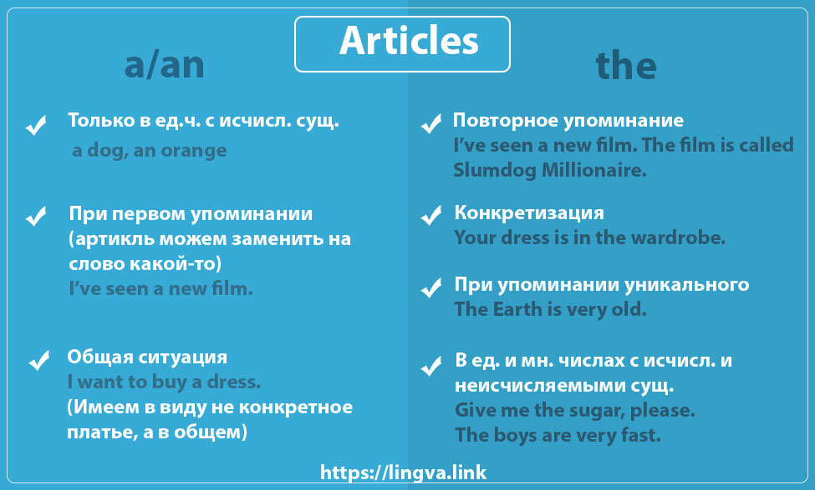
ТАБЛИЦА 5
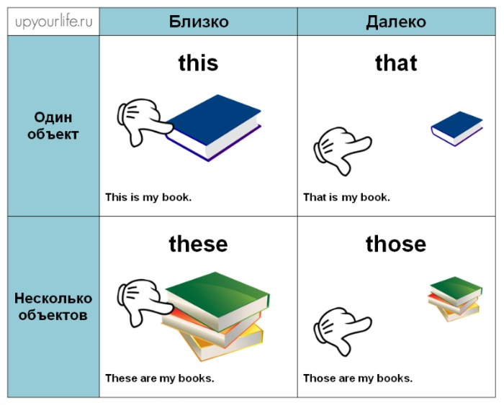

ТАБЛИЦА 6 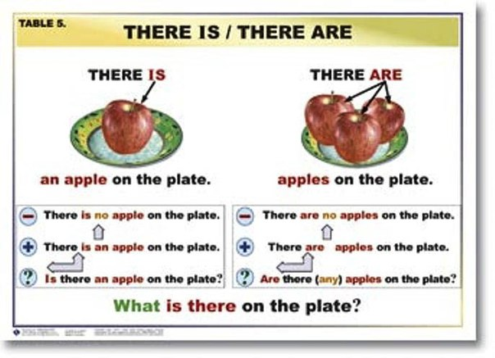
ТАБЛИЦА 7
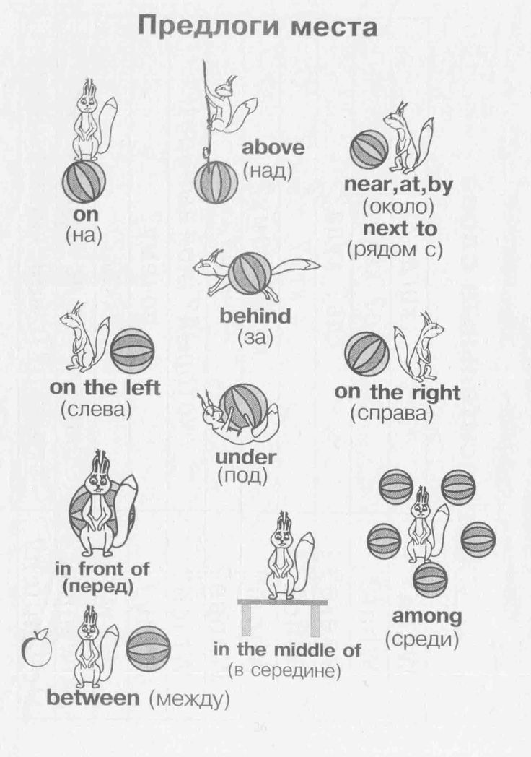

ТАБЛИЦА 8 PRESENT SIMPLE - Настоящее простое время
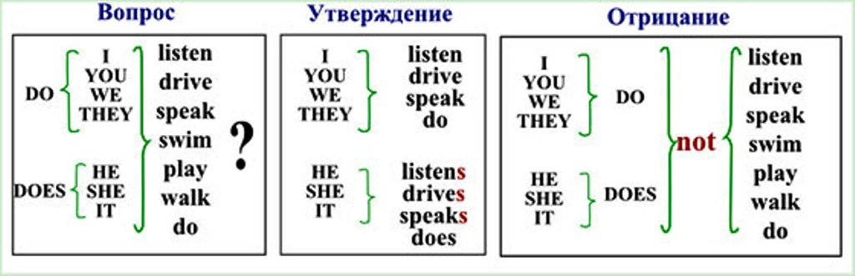
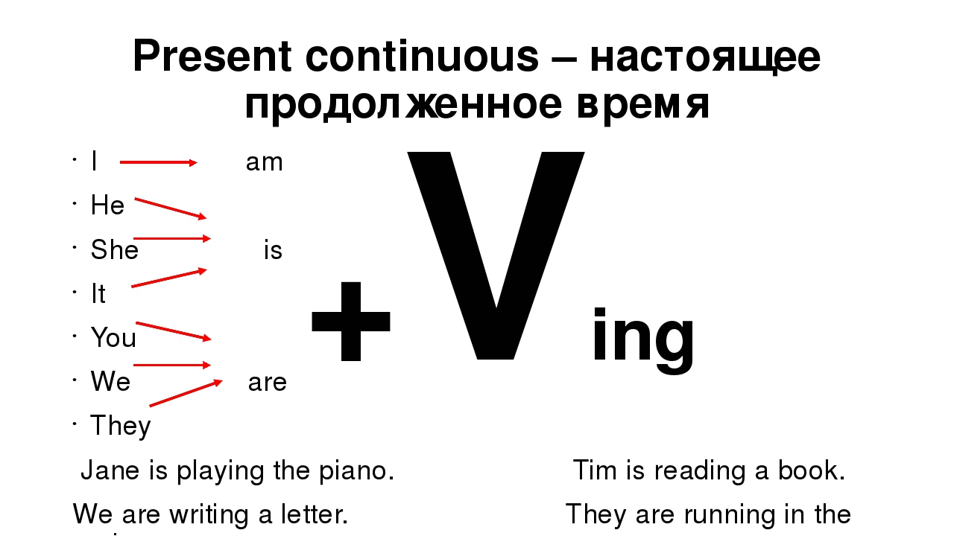
ТАБЛИЦА 9

- - утверждение

park.
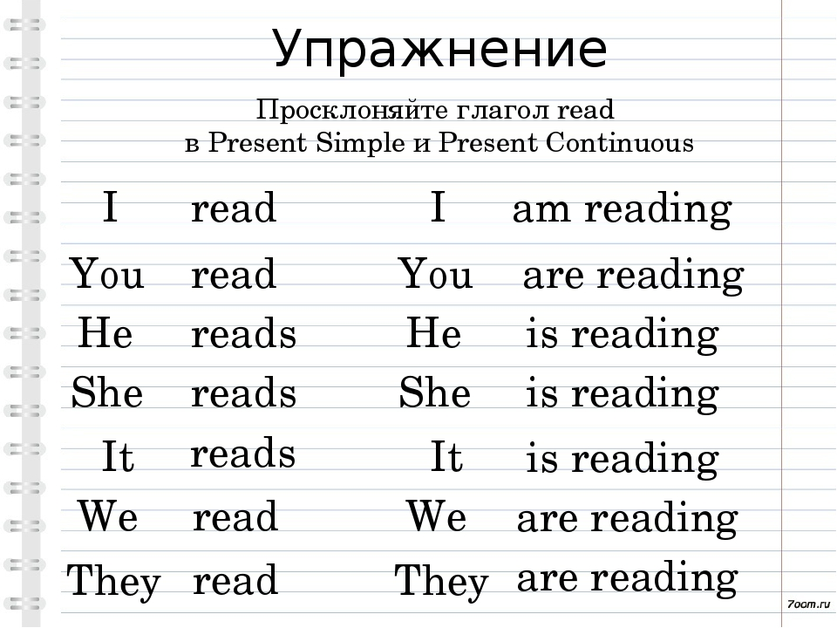

ТАБЛИЦА 10

